Communications & Messaging Programme
GP2GP Report
NCRS Phase 1 Release 2

Amendment History:

Version | Author | Date | Amendment History
0.1 | Els Briscoe | 29/01/04 | GP2GP record transfer options – Implementation options for discussion with Existing Systems Migration team – appendix to current version
0.2 | Els Briscoe | 17/3/04 | First draft after review of options meeting 13/2/04
0.3 | Els Briscoe | 23/3/04 | Final draft for formal review after informal review of v 0.2
1.0 | Els Briscoe | 26/03/04 | Approved
1.1 | Els Briscoe | 06/05/04 | Final for sign off – addresses review comments – addition of glossary and section 3.2 on new process without preserving anonymity
1.2 | Sarah King | 07/05/04 | PDS W5 document reference added
1.3 | Sarah Bagshaw | 10/05/04 | Additional minor changes and clarifications
2.0 |  | 10/05/04 | Approved

Approvals:
This document requires the following approvals.

Name | Signature | Title | Date of Issue | Version
Max Jones |  | Programme Head | 05/05/04 | 1.1
Margaret Baldock |  | Programme Manager | 05/05/04 | 1.1

Document Location
This document is only valid on the day it was printed. Please contact the Document Controller for location details or printing problems. This is a controlled document. On receipt of a new version, please destroy all previous versions (unless a specified earlier version is in use throughout the project).

© Crown Copyright 2004
Unauthorised copying, distribution, renting, lending or communicating to the public of all or a substantial part of any Crown Copyright material is prohibited. Licences for the use of Crown Copyright material are available from Her Majesty's Stationery Office, at http://www.hmso.gov.uk (click on 'Click-Use licences').

All trade marks and logos are the property of their respective owners. The use of any trade mark or logo without the prior written permission of the relevant owner is prohibited.

Contents

Glossary 4
1. Purpose of report 5
2. Assumptions 6
3. The registration and GP to GP record transfer process 7
3.1 The new GP2GP record transfer process (without anonymity) 7
3.2 The new GP2GP record transfer process (preserving anonymity) 16
3.3 Existing registration and record transfer processes 23
Appendix A : GP2GP record transfer options 27
Appendix B Issue Summary 38

Glossary

Personal Demographics Service | PDS | NHS wide demographics service which can be used by all NHS systems to identify a Service User and to supply that Service User’s personal details to Authorised User’s (As referenced by Module 2.1.1 of Schedule 1.1).
National Strategic Tracing Service | NSTS | A service provided to NHS organisations to trace and access patients' details, to obtain their NHS Number and a range of up-to-date administrative information.
National Health Applications & Infrastructure Services | NHAIS | The NHAIS Exeter System is a software suite used by all Health Authorities in England and Wales for the administration of cancer screening call/recall programmes and to deal with patient registration and contractor payments.
NHS Care Record | NHS CRS  NCRS | The NHS Care Records Service will provide all 50 million NHS patients with an individual electronic NHS Care Record, which will detail key treatments and care within either the health service or social care. For the first time, information about patients will be mobile - just like patients themselves - and not remain in filing stores in the buildings where treatment or care has been received.
Phase 2 (Release 1 and 2) | P2R1  P2R2 | In relation to a Project Agreement entered into between the Authority and the ICRS NASP or an LSP, the period from 1 January 2005 to 31 December 2006.
Transaction and Messaging Spine | TMS | The message handling application element of the Spine.
Spine Directory Services | SDS | The service elements specified in Part I, Module 350, which relate to the provision of a set of directories and gazetteers by the ICRA NASP to publicise and link the range of National Services and LSP Services available.
Royal College of General Practitioners | RCGP
National Clinical Advisory Board | NCAB

1. Purpose of report

This document forms the deliverable for the Detailed Business Analysis stage (W3) AND the Business Communication definition and refinement stage (W5) in accordance with the Communications & Messaging Programme Development methodology. The reason for this combined report is the advanced state of the existing development work on the GP2GP record transfer messages.

This report begins by setting out a list of assumptions related to the requirements to support the GP2GP record transfer process. Those assumptions have received some clinical validation but require wider consultation in particular where future process changes are suggested.

The document provides further:
- Descriptions and activity diagrams for the new GP2GP record transfer process. This consists of 2 versions: one that preserves anonymity of the new GP the patient has moved to and one that does not preserve anonymity. The latter was recommended by the GP2GP NCAB working group in consultation with other GP computing bodies, although formal ratification of this approach is still required.
- Detailed analysis of the new record transfer process
- Detailed specification in W5 format of the new messages proposed
- Description and activity diagrams for the existing registration and paper record transfer processes

The appendices hold a copy of the original GP2GP record transfer options document and also an Issue Summary table to aid the ongoing communication about and active resolution of issues related to this domain .

Please note that the names of the communications defined in this document have been updated to reflect the existing names of the current GP2GP message specification.

There are a variety of business rules around the process of transferring a patient’s records between GP practices in addition to the technical mechanism to achieve this. These rules will be drawn up by the GP2GP NCAB working group and validated with the wider primary care community and are not included in this report.

2. Assumptions

- The assumption remains that the ‘original’ requirements for GP2GP messaging have not changed, although it is recognised that there is a potential new requirement to support SNOMED CT in the messages. It has been agreed that whilst this requirement may not be urgent in the short term, it would be preferable to address the requirement now and provide long term benefit.
- The original requirements for GP2GP messaging included the requirement to deal with multiple transfers efficiently and safely. Multiple transfers frequently happen e.g. student registration at start of studies – transfer of record – few additional record entries – at end of studies student moves back to previous registration – inevitable degrading of structure of the information . The existing GP2GP message specification provides a technical solution to address this requirement, however further validation of this solution will be required through supplier testing.
- It is assumed that there will continue to be a requirement to transfer the paper record as per existing processes until such time as all patient records in GP practices are electronic
- It is assumed in phase 1 release 2 there will be no direct update of PDS in view of new registration but a PDS update via NSTS. The phasing out of NHSCR and NSTS in Phase 2 will change this process and it is assumed in P2R1 NHAIS will directly update PDS.
- For temporary residents the paper record is currently not transferred. It is assumed that although it would be possible with NCRS to send the record electronically it is assumed that the GP2GP record transfer messages will not be used for this scenario in a first phase of NCRS implementation
- It is assumed that special cases of record transfer will continue to be dealt with as per existing processes for Phase 1 release 2 . The migration strategy for NHAIS functionality and PDS functionality will inform future message specifications in the domain of Existing Systems.
- Authentication and access control will form part of the GP2GP record transfer process e.g. there will be a check on the authorisation of the requestor to request a patient record. If this is negative then the record transfer response will hold a reject code which indicates that there is no user permission.
- Authentication and access control data items specified in the messages are subject to change and will be standardised for all messages

3. The registration and GP to GP record transfer process

Current processes through the NHAIS route combine registration changes and record transfer into one process. A review of the possible options for the implementation of the electronic GP2GP message recommended an approach for P1R2 which combines the electronic record transfer messages via NCRS with the existing registration and (paper) record flows via NHAIS and postal services. (Appendix A)
Relevant supporting functionality in NHAIS will be phased out in later phases of NCRS implementation and is depending on the migration strategy for PDS and the transport of the physical, paper record (Lloyd George envelope).

3.1 The new GP2GP record transfer process (without anonymity)

The GP2GP NCAB working group’s recommendation on the GP to GP record transfer process is that it can see no professional reason to preserve the anonymity of the new GP practice the patient has moved to. This will simplify the process, reduce the role of TMS and places more emphasis on the role of GP systems to access PDS and SDS.

3.1.1 Process description

A patient presents at a GP surgery and request a new registration with the surgery. If the registration is accepted then firstly the PDS is queried to retrieve existing demographics, NHS number and existing registration details. This information is used to register the patient on the GP system. This triggers a query from the GP system to SDS to check if the practice with whom the patient was previously registered is NCRS compliant for GP2GP messages. If the SDS check is positive then this will automatically trigger the request to be sent directly via the TMS to the previously registered GP practice system. If the SDS check is negative then the GP system will inform the user that no electronic transfer of the existing GP record is possible. On receipt of a record request, the receiving GP will, after consideration of the request, send an EHR request acknowledgement that indicates if and when the request will be actioned. The electronic transfer of the EHR Extract message which contains the existing GP record will follow as indicated by the acknowledgement code contained in the EHR Request acknowledgement . The paper record will in all cases follow the current process
3.1.2 Activity diagram
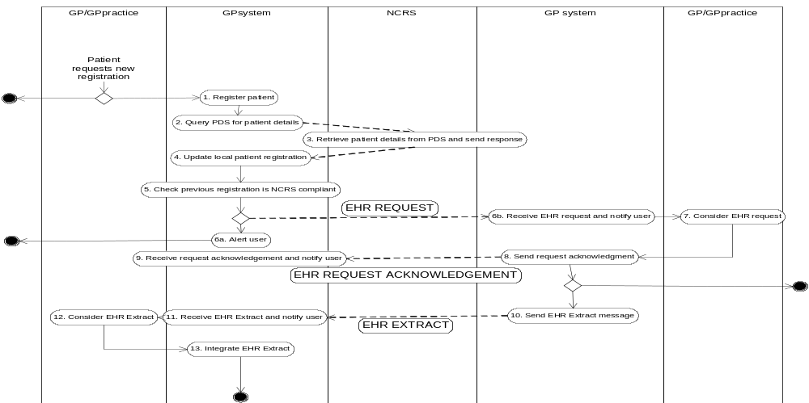

3.1.3 Analysis of activities
Start of process: A patient requests a registration with a GP/ GP practice

Decision: The GP/GP practice decides to either accept or reject a request for registration

Activity 1 Register new patient
Actor: GP practice/GP system
Description: If the request for registration is accepted the patient will be registered on the local GP system

Activity 2 Query PDS for patient details
Actor : GP system
Description : As part of the local registration process , the PDS is queried for the patient’s up to date details e.g demographics, NHS number and current registration details

Trigger for business communication : PDS query ( specified in PDS business communications definition document – reference NPFIT-NDA-COM-RZ-0092)

Activity 3 Retrieve patient details from PDS and send response
Actor : NCRS
Description : The TMS will route the query to PDS which will populate a response message with the available patient details

Trigger for business communication : PDS query response (specified in PDS business communications definition document – reference NPFIT-NDA-COM-RZ-0092)

Activity 4 Update local patient registration
Actor : GP system
Description : The patient demographics and NHS number content of the PDS query response is integrated in the local system

Note : If no record of the patient exists on PDS then a new entry will be created ( see PDS documents) and appropriate PDS update messages sent .

Activity 5 Check previous registration is NCRS compliant
Actor : GP system
Description : The GP system will interrogate SDS to find out if the practice system with which the patient was previously registered is NCRS compliant for GP2GP record transfer messages

Decision : Determined by SDS response .

Issue :the registration details available from PDS in P1R2 are the registered GP code . It is known at present if SDS will be able to determine GP system details from a registered GP code
Issue : Note that interactions between local systems and SDS are not HL7 messages and there may be inaccuracies in the process described here e.g it is possible that the SDS interaction takes place as part of each message that is triggered e.g. find system details and check that is compliant for this message..

Activity 6a Alert user
Actor : GP system
Description : If the SDS response is negative e.g the practice system is unable to send/receive GP2GP record transfer messages then the GP system will alert the user to the fact that no electronic transfer of the existing patient record is available .

Process Issue : Rules will need to be determined on the actions required when a GP system at some point in the future becomes NCRS compliant . Does this need to be notified to those that would have requested but could not at the time ? Only local systems can have a record since no message is actually sent . Should the record still be sent ?

Activity 6b Send EHR request
Actor : GP system
Description : A positive SDS response will trigger a record transfer request to be sent to GP practice system with which the patient was previously registered

Activity 7 Receive EHR request and alert user
Actor : GP system
Description : GP system will receive the request and alert appropriate users to the request.

Activity 8 Consider EHR request
Actor : GP /GP practice
Description : Process for dealing with EHR requests . To be determined – NCAB input

Activity 9 Send EHR request acknowledgement
Actor : GP system/GP
Description : The GP system will send an acknowledgement of receipt of the request which indicates the response to the EHR request.

Activity 10 Receive EHR request acknowledgement and notify user
Actor : GP system
Description : The GP system will receive the acknowledgement and alert appropriate users to the receipt

Activity 11 Send EHR extract
Actor : GP system
Description : If the request can be fulfilled the GP system will send the patient’s Primary care record as an EHR extract message to the requestor

Activity 12 Receive EHR extract and notify user
Actor : GP system
Description : The GP system will receive an EHR extract and notify appropriate users to the receipt

Activity 13 Consider EHR extract
Actor : GP
Description: Process for dealing with EHR extracts received – To be determined

Activity 14 Integrate received patient record
Actor : GP system
Description : Process/ integration rules for received patient records – to be determined

3.1.4 Analysis of business communications

- EHR request: as specified in 3.1.4.1
- EHR request acknowledgement : as specified in 3.1.4.2
- EHR extract : as per existing specification – see 3.1.4.3

3.1.4.1 EHR request

Purpose
To request an electronic transfer of a patient’s Primary Care Record.

Business Communication Requirement

Communication Name | EHR request
Sending Role | Request Sender
Trigger Event | The registration of a new patient on a GP system
Communication Type | Request
Receiving Role | Request Responder

Business Communication Content

Level | Name Item / Group | Definition | Example | Representation | Cardinality | Constraints & Dependencies | Default value | Null required | Outstanding issues
1 | Request message ID | Unique identifier for the request message |  | UUID | 1..1
2 | Request Originator Information |  |  | Identifier | 1..1
2.1 | Organisation Code | SDS code for the GP practice from which the request originated |  | SDS organisation identifier | 1..1
2.2 | User Unique identifier | SDS user identifier for care professional sending the request |  | SDS user ID | 1..1
2.3 | Role Profile ID | The (RBAC) role assigned to the care professional at the time of the request |  | SDS role profile ID | 1..1
3 | Destination information |  |  |  | 1..1
3.1 | Organisation Code | GP practice to which request is addressed |  | SDS organisation identifier
3.2 | User Unique identifier | SDS user identifier for care professional to whom the request is addressed |  | SDS user ID |  |  |  |  | In the future patients will be registered with GP practices and not with individual GPs so 3.2 and 3.3 may not be required
3.3 | Role Profile ID | The (RBAC) role assigned to the care professional at the time of the request |  | SDS role profile ID |  |  |  |  | Will this be known to the sender ???
4 | Individual Patient Information |  |  |  | 1..1
4.1 | NHS Number | NHS Number |  | DD NHS Number | 1..1

3.1.4.2 EHR request acknowledgement

Purpose
To acknowledge receipt of an EHR request and indicate to the requestor the response to the request

Business Communication Requirement

Communication Name | EHR request acknowledgement
Sending Role | EHR Request Receiver
Trigger Event | The receipt of an EHR request and consideration of the EHR request
Communication Type | Response
Receiving Role | EHR Requestor

Business Communication Content

Level | Name Item / Group | Definition | Example | Representation | Cardinality | Constraints & Dependencies | Default value | Null required | Outstanding issues
1 | Request message ID | Unique identifier for the request message |  | UUID | 1..1
2 | EHR Request Acknowledgement code | To indicate the type of request acknowledgement information |  | Coded value | 1..1 | Suggested code list :  1. Record available and to be sent immediately (e.g. 24 hours)  2. Record available and to be sent soon (within 1 week)  3. record available but cannot be sent  4. record unavailable  5. record lost  6. patient not at surgery |  |  | This coded list has not been reviewed and may require mapping to Snomed –  Processes for dealing with acknowledgment codes 3 and 6 will need to be determined

3.1.4.3 EHR Extract

This message is represented by the current EHR Extract message from the NHS GP2GP project as defined June 2003.

The specification of the EHR Extract message has reached an advanced state of development as a result of the GP2GP message Project which included a degree of validation and testing. The GP2GP message in its design was developed to support clinical statements as derived from GP systems. There is no requirement to detail the list of data items for this message as the Core Technical Team (CTT) do not require this level of detail to build the full message as it currently exists.

The existing EHR extract specification can be accessed from HL7uk website.

In order to align the message with more recent developments in HL7 and NPfIT clinical statement development, a piece of work is being undertaken by the Core Technical Team to review the message model and make appropriate changes to the models and schemas to bring them into alignment with the NPfIT Message Implementation Manual. Changes will be fully documented and released with the P1R2 message pack on May 10th.

3.2 The new GP2GP record transfer process (preserving anonymity)
This process is included in the document only for information purposes since recent developments confirm the new GP2GP record transfer process as described above.

3.2.1 Process description

A patient presents at a GP surgery and request a new registration with the surgery. If the practice accepts the new patient, a record transfer request is sent to NCRS. The TMS on receipt of the message retrieves the details of the existing GP registration from PDS and checks that the practice is NCRS compliant and can receive and send the GP2GP messages. If positive the TMS will forward the record transfer request to the identified GP practice which on receipt of the request will send a record transfer response which incorporates the full local patient record. If negative e.g. no existing GP registration available or the GP practice system is non NCRS compliant then NCRS will send a record transfer response which indicates no electronic patient record can be sent. The transfer of the paper record will in both cases follow the current process. (See existing registration and record flows)

3.2. 2 Activity diagram 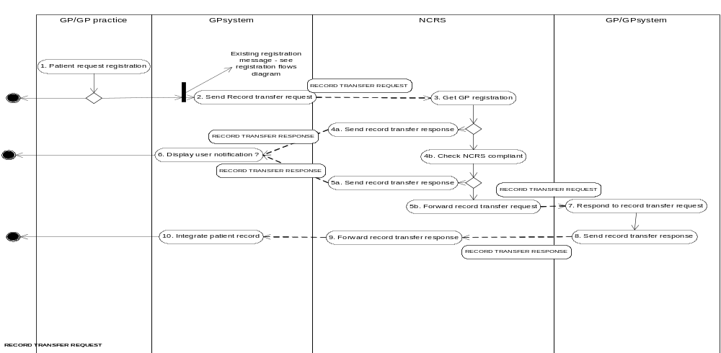

3.1.3 Analysis of activities

Start of process: A patient requests a registration with a GP/ GP practice

Decision: The GP/GP practice decides to either accept or reject a request for registration

Activity 1 Register new patient
Actor: GP practice/GP system
Description: If the request for registration is accepted the patient will be registered on the local GP system

Trigger for business communication : GP2GP record transfer request
Note that this is also the trigger for the GP system to send an Acceptance transaction type (Edifact) message to the local NHAIS system – see existing registration flow diagrams

Activity 2 Send record transfer request
Actor: GP system
Description: The GP system will send the record transfer request to the NSCR

Activity 3 Get GP registration
Actor: NSCR/ PDS
Description: On receipt of the message by TMS, the existing registration details of the patient are retrieved from the PDS

Decision: Triggered by availability of previous registration details on PDS

Assumption : It is assumed that this is a function for national systems but is it possible that GP systems could retrieve the previous registration from PDS . There is still the need however to consult the SDS for NCRS compliance.

Activity 4a Send record transfer response
Actor: NSCR/PDS
Description: If no existing registration details are available on PDS then a response message is sent to the requesting GP system informing that no electronic transfer of the record is possible.

Activity 4b Check NCRS compliant
Actor: NSCR/SDS
Description: A check is made in the SDS if the registered GP/GP practice has a system that is NCRS compliant for the sending and receiving of GP2GP record transfer messages

Decision: triggered by the NCRS compliance of the registered GP/ GP Practice system

Assumption: It is assumed that this is a function for national systems but is it possible that GP systems could check SDS on receipt of the previous registration details from PDS .

Issue: assumptions for activities 3, 4 and 5 have not been confirmed by DA and suppliers

Activity 5a: Send record transfer response
Actor: NSCR
Description: If the registered GP practice system is not NCRS compliant for this message type then a response message is sent to the requesting GP system informing that no electronic transfer of the record is possible

Note: This is a variation on activity 4a

Activity 5b Forward record transfer request
Actor: TMS
Description: The TMS will forward the record transfer request to the registered GP practice system

Note : Currently in the record transfer process, the details of the new registration are not communicated to the previously registered GP. If the anonymity of the new registration is be maintained then the NCRS/TMS would need to remove details of the requester from the record transfer request message and on receipt of a fulfilled record transfer response , the TMS would be responsible for forwarding the response to the correct requestor

Activity 6 Display user notification
Actor: GP system
Description: On receipt of a record transfer response that indicates a rejection of the request as per activity 4a and 5a, the GP system will inform the GP by displaying a user notification

Assumption: it is assumed that the user will be informed if no electronic transfer of the record is possible

Activity 7 Respond to record transfer request
Actor GP system
Description: On receipt of a record transfer request the GP system will populate the response message with the local patient record for that patient

Activity 8 Send record transfer response
Actor; GP system
Description: The GP system sends the record transfer response to the TMS

Note: The activity diagram reflects the current process of maintaining anonymity of the new registration. If it was decided this was no longer necessary then the message could go direct to the requestor and the role of TMS/NCRS is reduced.

Activity 9 Forward record transfer response
Actor TMS
Description: The TMS will forward the record transfer response to the requesting GP practice. If details of the requester are not made available to the sending GP practice then the TMS will need to take responsibility that the response is sent to the appropriate requestor

Activity 10 Integrate patient record
Actor GP system
Description: On receipt of a record transfer response that contains a patient’s record, the receiving GP system will integrate the content of the record into the local system

3.2.4 Analysis of business communications

GP2GPRecord transfer request: this is a new message which will flow in the context of GP to NCRS - see 3.1.4.1 EHR request
GP2GPRecord transfer response (not fulfilled): this is a new message which will flow in the context of NCRS to GP - see full specification below
GP2GPRecord transfer response (fulfilled): see 3.1.4.3 EHR Extract

3.2.4.1 GP2GP Record transfer response (not fulfilled)

Purpose
To respond to a request for an electronic transfer of a patient’s Primary Care Record which cannot be fulfilled.

Note :

Business Communication Requirement

Communication Name | GP2GP record transfer response
Sending Role | Request Responder
Trigger Event | The receipt of a request for record transfer which cannot be fulfilled
Communication Type | Response
Receiving Role | Request Sender

Business Communication Content

Level | Name Item / Group | Definition | Example | Representation | Cardinality | Constraints & Dependencies | Default value | Null required | Outstanding issues
1 | Request message ID | Unique identifier for the request message |  | UUID | 1..1
2. | Response Code | Coded reason for non fulfilment of the request |  | Code | 1..1 | Value list for codes : no user permission, no previous registration , not NCRS compliant |  |  | Codes to be agreed  Could be combined with a code for a positive response

3.3 Existing registration and record transfer processes

3.3.1 Process Description

When a new registration is entered on the GP system, an Acceptance Transaction Type message (EDIFACT) is sent to the local NHAIS system which in response updates its own records and confirms the new registration and the patients’ NHS number to the GP practice. The NHAIS system sends an Incremental Transaction Type message to NSTS which in turn updates the PDS. If the patient was previously registered with a GP practice that belonged to the same local NHAIS system then a Deduction Transaction Type message is sent to the previously registered GP practice. On receipt of this message the patient will be taken off the patient list for that GP practice and the patient’s paper record (Lloyd George) will be sent to NHAIS who then forward the paper record to the new GP practice. If the local NHAIS system has no record of a previous registration for the patient then an Acceptance notification (not EDIFACT) is sent to NHSCR to find the latest posting of the patient. NHSCR will then send a Deduction notification (not EDIFACT) to the NHAIS system that held the previous patient registration. The NHAIS system in turn sends a Deduction Transaction Type message to the GP practice who on receipt will take the patient off the patient list and send the patient’s paper record to NHAIS who will forward the record to the ‘new’ local NHAIS who will then forward it to the ‘new’ GP practice.

3.3.2 Activity diagrams

Scenario 1 Patient moves to a new GP within the geographic area covered by a single NHAIS system.

Scenario 2 Patient moves to a new GP outside of the geographic area covered by a single NHAIS system

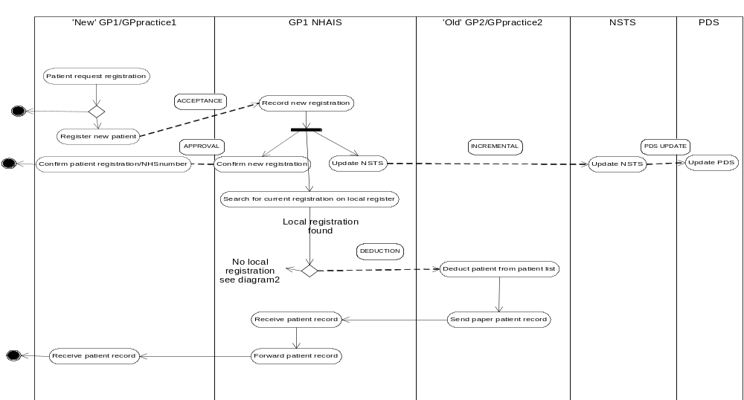
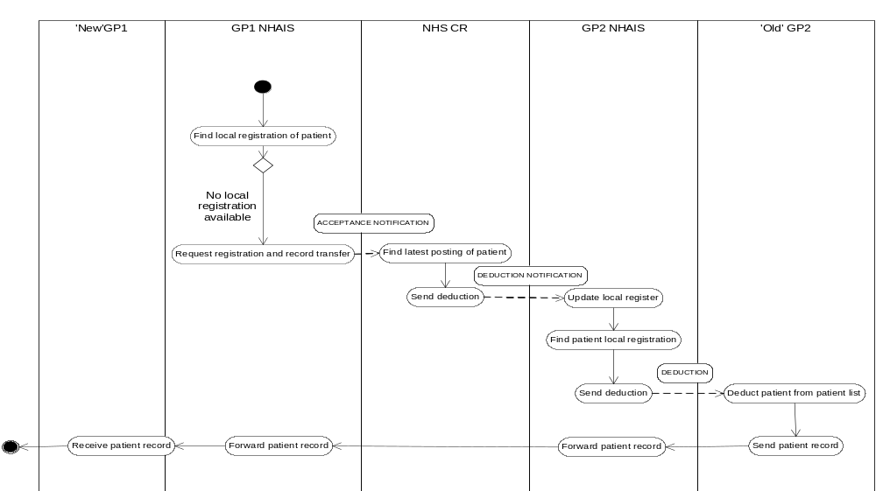

3.3.3 Notes about current registration and record transfer processes

1. The existing process as per scenario 1 will change in P2 R1 to exclude interaction between NHAIS and NSTS and NHAIS will directly update PDS

2. Special cases of registration and record transfer
- patient in prison – will be assigned a GP – can use defined messages
- patient in armed services and service dependant records- no MR sent to army for service men but service dependant records do get sent
- patient gone to live abroad – records held by last posted NHAIS system
- patient is suspected to have gone away –
- mental health inpatient
- moving to other parts of UK e.g. Wales , Scotland

It is assumed that special cases of record transfer will continue to be dealt with as per existing processes for Phase 1 release 2. The migration strategy for NHAIS functionality and PDS functionality will inform future message specifications in this area and will be documented in the domain of Existing Systems.

Appendix A : GP2GP record transfer options

(Please note that this paper has been included as additional historical information and the approach to be adopted for GP2GP record transfer is outlined in the main body of the report. The GP2GP messages in MiM support this approach.)

GP2GP record transfer – options
29/01/2004

This paper explores the differ options for implementation of the GP2GP record transfer message.
Whilst the message has been developed through previous work, there is a requirement to understand how the message fits with existing and future links between existing national systems in particular NHAIS and CR and the new ICRS systems in particular PDS. There is a need to understand the triggers for the message and the supporting registration flows that are required in this new environment.

Current process
The current process is supported by the ‘Lloyd George’ scheme, whereby patient records are printed by a patient’s original GP practice, and posted to the new GP practice via the Health Authorities and Clinical Register. A series of flags at the two Exeter systems are used to record the state of the transfer of the patient record.
The activity diagram below details the steps of the existing process

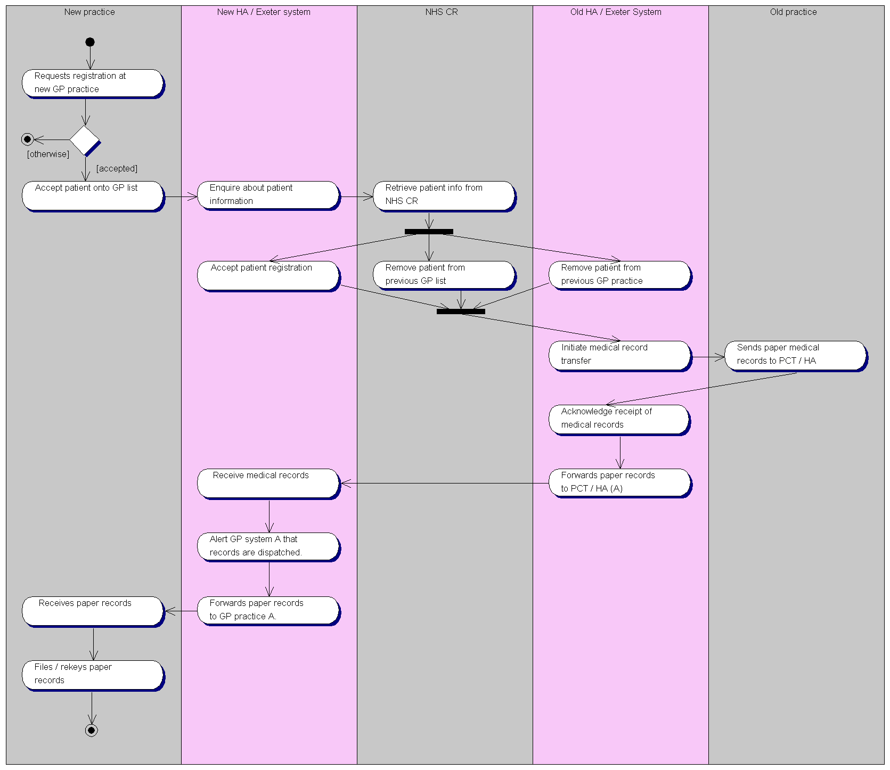

2. Electronic GP2GP record transfer – options

2. 1. GP2GP option 1

This process looks at electronic record transfer in an environment without ICRS and considers only the parties currently involved in the Lloyd George process as senders and receivers of the GP2GP messages.

Considerations

- The update to PDS could follow in this option 1 the migration path for NSTS data e.g. regular updates from NSTS to PDS will update the patient’s NHS Care Record registration details;
- There is no opportunity to update the patient PSIS (clinical) data ( through copy or extracts) since the record transfer message does not pass through TMS .
- It was our assumption that ALL messages would be routed through TMS and as such security (encryption and access control) would be provided for all messages. Current GP2GP messages include security features. Existing registration messages between GPs and NHAIS use their own security measures.
- Current systems such as CR and NSTS are due to be phased out in a relatively short time period. This option places the obligation on those systems to implement the GP2GP messages
- The triggers for sending the messages and the application roles will need to be defined for each system involved
- The registration updates and the request for the record transfer are not separated in this option and it is not clear if the transfer request carries the same information in all occurrences of the message
- This option does not make use of the opportunities offered by the new ICRS environment ( see other options)

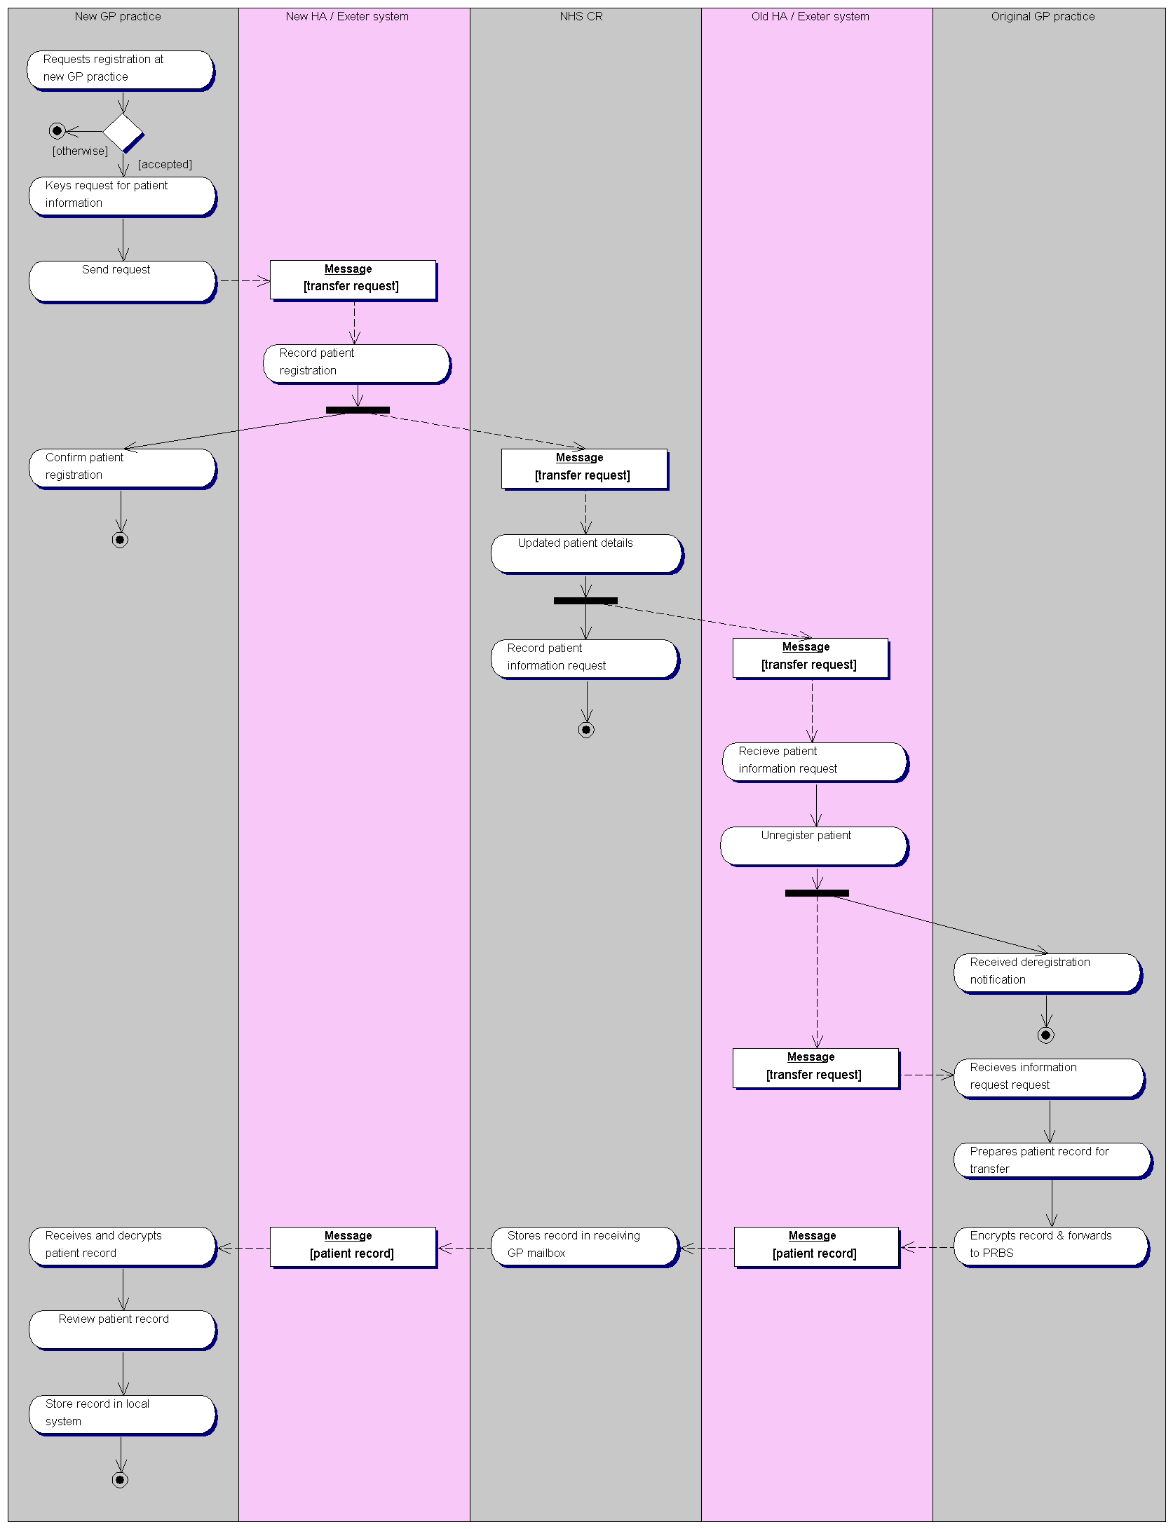

2.2 GP2GP option 2

In this option the TMS/PDS fulfils a major role in the routing of the GP2GP messages AND a change is proposed to the flow of patient registration details to existing systems.

Considerations

- TMS is responsible for routing the registration notification to the relevant NHAIS systems e.g. the old and new HA so they can update their records
- TMS could also route the registration notification directly to CR, alternatively this could happen via existing links between NHAIS and CR
- TMS is responsible for sending the GP2GP record request message to the previously registered GP so this request message is triggered through the receipt of the registration notification and the subsequent retrieval of the previous registration details from PDS. PDS will hold the details of the current registered GP (or practice) for a patient.
- Note that a registration notification could also be for a first registration in which case only the new HA (and CR) would need informing.
- Existing links between HA and GPs would not be needed as TMS would update HA’s and the GP’s.
- The patient’s record is transferred directly between the GPs involved and does not require storage in a central location thus speeding up the process of transfer
- The patient’s NHS Care record is directly updated with new registration details and does not depend on the NSTS feeds for this data
- It is possible to take a copy or extract from the GP2GP record transfer message to populate a patient’s PSIS (clinical) record
- If a patient record can not be sent in response to a request ( due to system limitations) then a response needs to go to the new GP to inform him/her that the patient’s record will be transferred via postal ? route. The paper record would not need to be transferred via the HA/CR but could go directly to the new GP since his/her details are known through the request.

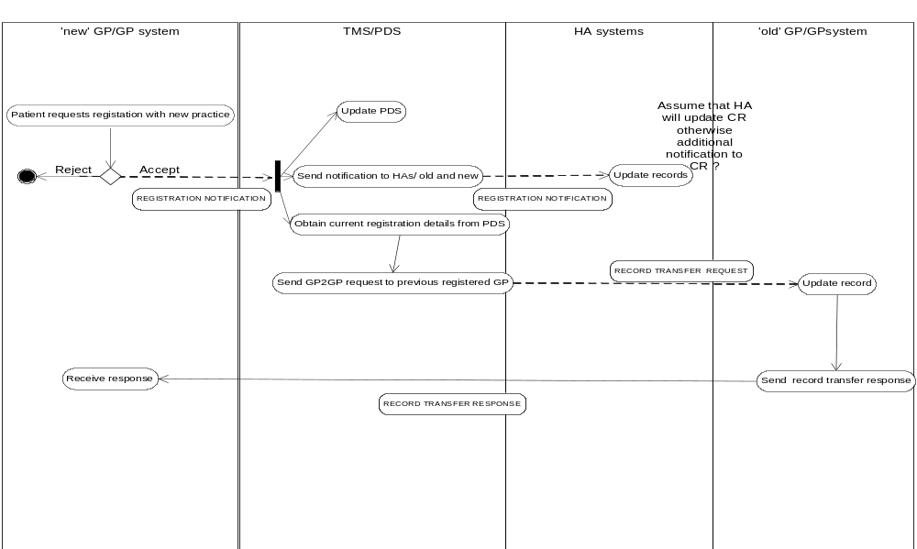

2.3 GP2GP option 3

In this option the NHAIS (or CR) system is the principal actor in sending the GP2GP messages and PDS/PSIS is updated by the fact that the message is sent via TMS which takes a copy of the registration notification and a copy/extracts from the GP record transfer message when these messages are communicated between the GP systems. (this is a variation on option 1)

Considerations

- Existing registration messages( EDIFACT between GPs and NHAIS) , if routed via TMS could directly update PDS
- GP2GP record transfer messages would be following the same information flow as the registration messages so if a record can not be sent in response to a request, then the manual process can be followed which needs to include CR/NHAIS.
- Main responsibility for implementing the GP2GP messages is NHAIS/CR , TMS has no other role then direct routing
- NHAIS/CR remain in control of registration details and the subsequent release of the patient record since they trigger the GP2GP messages.
- PSIS and PDS are updated by taking copies/extracts when the messages pass through TMS

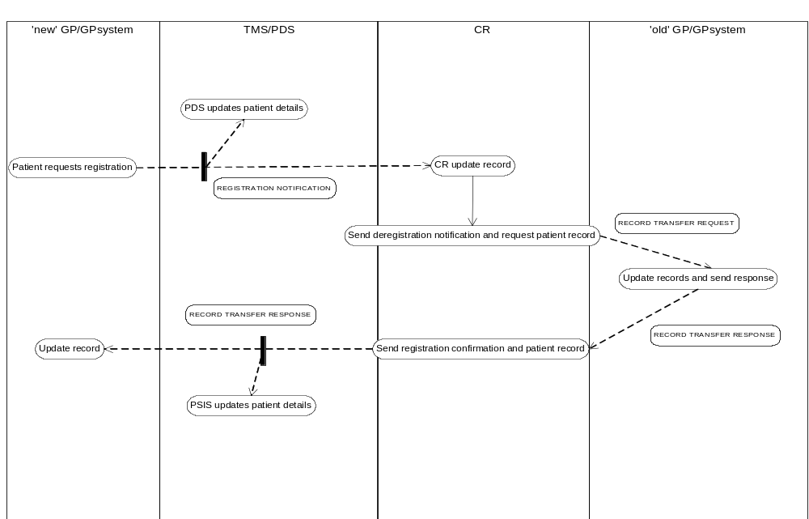

2.4 GP2GP option 4

In this option the responsibility for the functionality of registration and that of transferring the patient’s record is divided between existing systems and the ICRS systems. Existing systems continue to be updated by existing GP registration messages and procedures and PDS is updated via the NSTS link.
The GP2GP record transfer messages are sent by GP systems and routed by the TMS to the appropriate GP.

Considerations

- a TMS rule could be devised that it will not send the record transfer request till a PDS update is received which confirms the new registration
- There is no need for NHAIS and CR to be able to send and receive the GP2GP messages .
- Existing electronic messages can continue to be used till such time as the functionality of NHAIS/CR can be taken on by ICRS systems
- If a record can not be sent then current procedures can be followed.

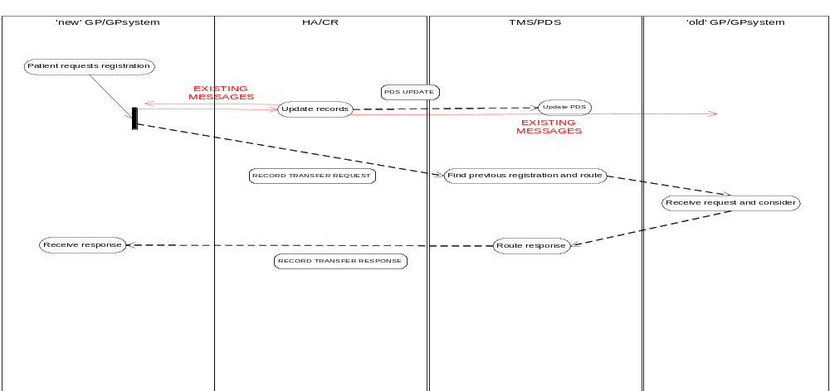

Appendix B Issue Summary

Issue | Status issue and date | Comments
The registration details available from PDS in P1R2 are the registered GP code . It is not known at present if SDS will be able to determine GP system details from a registered GP code | Ongoing – 06/05/04 | Assigned to PDS Lead, Technology Office
Interactions between local systems and SDS are not HL7 messages and there may be inaccuracies in the process described here e.g it is possible that the SDS interaction takes place as part of each message that is triggered e.g. find system details and check that is compliant for this message.. | Ongoing – 060504 | Raised as a programme issue as it affects all messages Awaiting further clarification on how SDS will interact with local systems and HL7 messages
Process Issue : Rules will need to be determined on the actions required when a GP system at some point in the future becomes NCRS compliant | Ongoing / assigned – 060504 | Assigned to the NCAB GP2GP working group who agreed to look at specific process issues
Process for dealing with EHR requests . To be determined – NCAB input | Ongoing / assigned – 060504 | Assigned to the NCAB GP2GP working group who agreed to look at specific process issues
Process for dealing with EHR extracts and how these should be integrate with local records needs to be determined | Ongoing – 060504 | This issue is related to multiple transfers, the technical solution proposed will need to be tested and evaluated
This acknowledgement coded list has not been reviewed and may require mapping to Snomed – | Ongoing -060504 | Not assigned due to the fact that the requirement for an acknowledgement has only recently been confirmed
Processes for dealing with acknowledgment codes 3 and 6 will need to be determined | Ongoing -060504 | Not assigned due to the fact that the requirement for an acknowledgement has only recently been confirmed

This report has been reviewed by members of the NCAB working group for GP2GP record transfer and NPfIT clinicians
From GP2GP scoping report v 0.21

